Home Work – 2

Scientific Visualization Homework1

Data Visualization

Rohit Das

61047086s

National Taiwan Normal university

* Backpack Scan Dataset

Objects Found:

1. Coke Bottle
2. Small Flask
3. Big Can
4. Wires
5. An open-top Box
6. Nail
7. Zippers
8. Headphones
9. Spring
10. A circuit box with wires inside

* Deep Water Simulation Dataset

1. Visualize size of the tsunami wave at this moment.

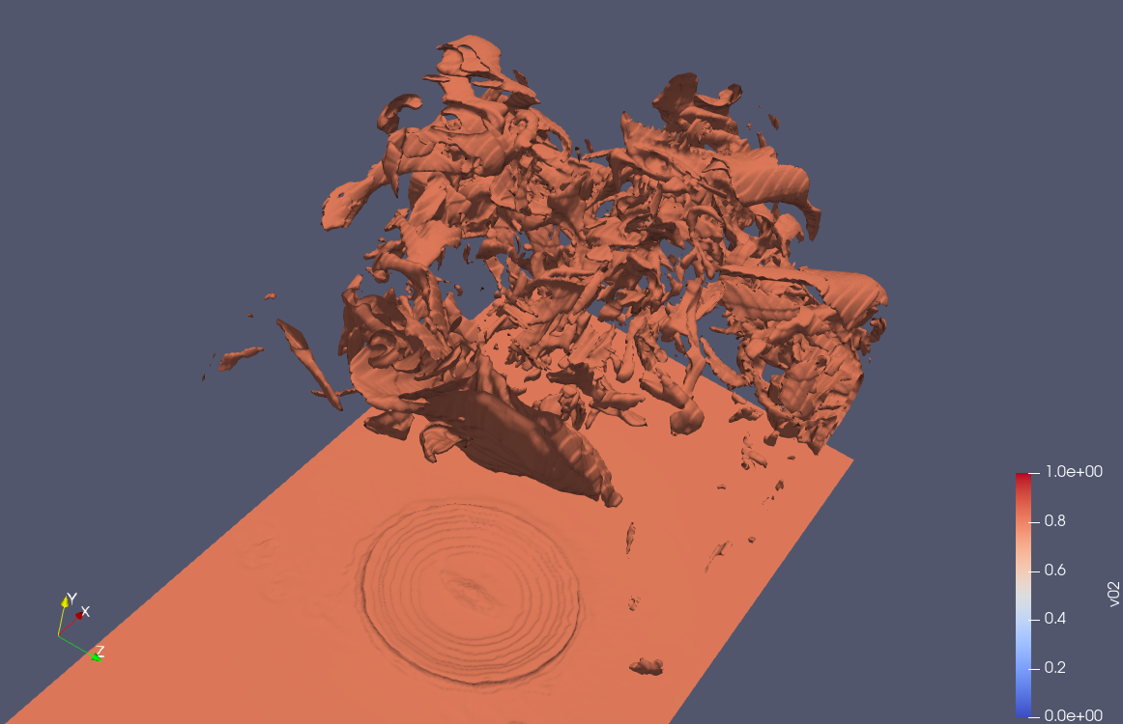

1. Does the temperature of the region inside the tsunami wave ring is higher than that of neighbouring ocean region?

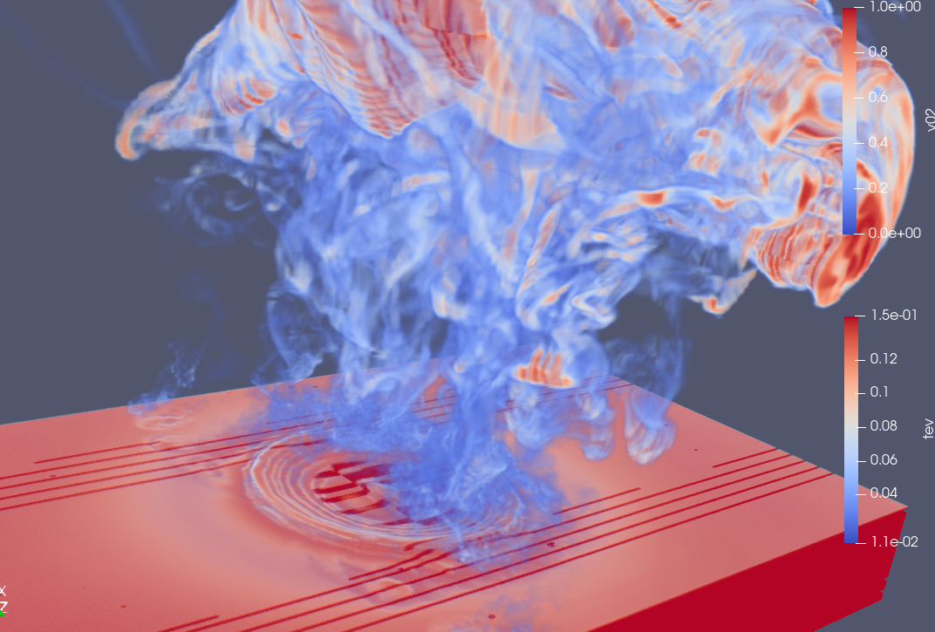

Since “v02” resembles the volume fraction water and “tev” resembles the temperature in electronvolt, I tried using contour method to figure out the temperature, but unfortunately, I couldn’t find any concrete results.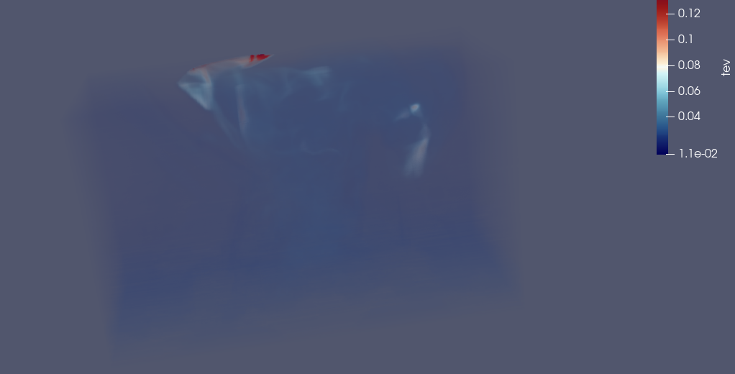

Further research led me to the idea that the “tev” data itself doesn’t show much information either. Maybe the asteroid just hit the water that’s why it didn’t heated up yet.

But then I found another data called “prs” which is pressure.

As we already know that low pressure equals to high temperature. So, I conclude that when the asteroid hit, the inner and outer ring has more low pressure than the neighbour areas.

